Castle Siege

Rulebook

Preparation:

Players are divided into two teams. Each team builds a castle with at least 12 blocks. Building close to a wall is recommended.

Requirements:

The castle must be at least 3 levels high. Each level must have at least one upright block. All the blocks must be contiguous. There can’t be flat blocks laying at the base.

Picture below can be used as a reference.

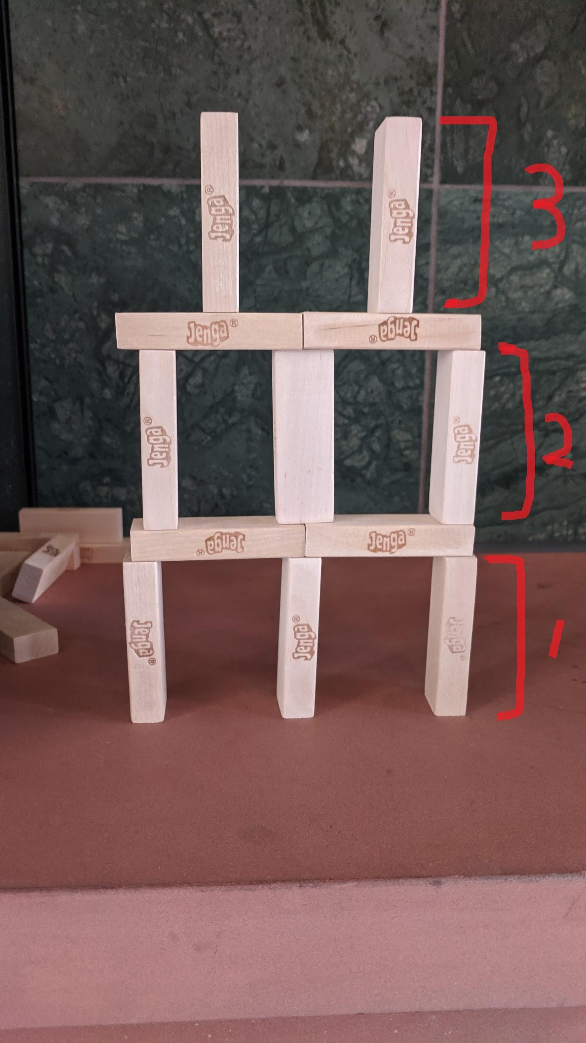

How to play:

Each team needs to shoot down the other team’s castle from around 12 feet away with a band.

You can use the band in anyway you like as long as there are no other items used.

Each team has 8 shots.

As a reference, this could be a possible way to do this:

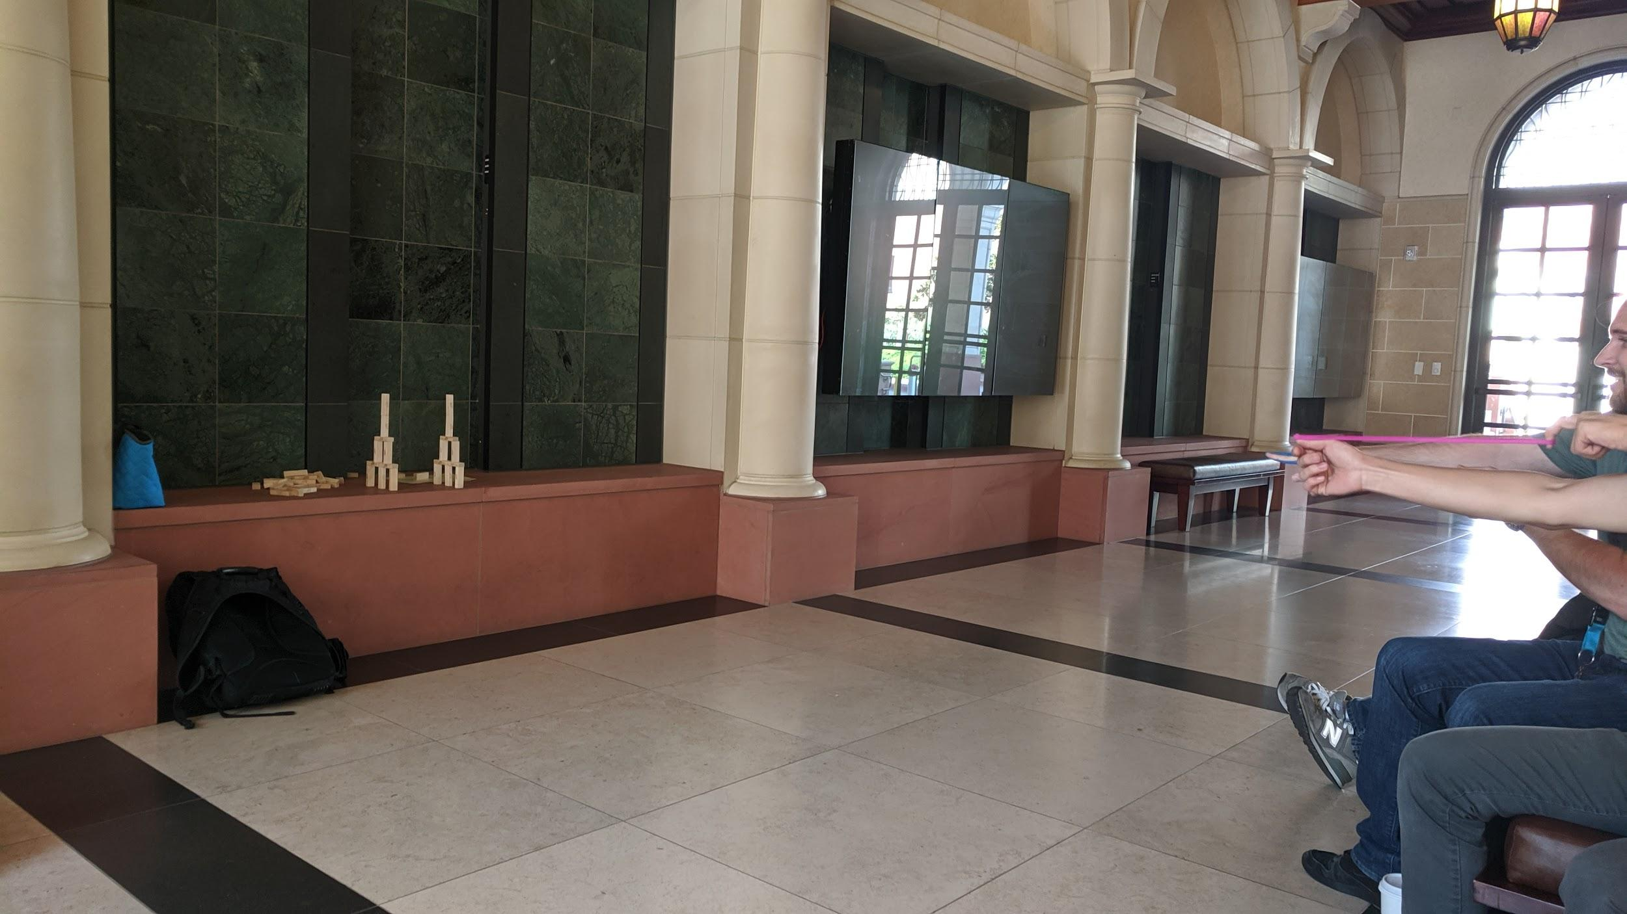

Game result:

The team that shoots down all the blocks with fewer shots wins the game.

If neither completes within 8 shots, the team that topples more blocks wins the game.